# ACCTLA Website Admin Guide

## Menus

## Adding/Editing pages

## Adding/Editing events

## Creating Cases/Verdicts

## Adding “The Verdict” Publication

## Creating/Editing Members

Test Credentials

**URL:** <http://agdesigngroup.net/clients/acctla/wp-admin/>

**UN** **PW**

Admin Nimda!

Sustaining Niatsus!

Normal Amron!

## Menus

1. Theme Locations – Select which menu you want to appear in each location.
   1. Primary Navigation (Primary) – Main Top Navigation
   2. Sign up – Join Us/Signup Button
   3. Header Sub – Top left submenu ( home, contact, etc. )
   4. Membership – Sustaining Member button
   5. Page Menu (Page) – Navigation for basic content page
   6. Footer – Copyright and Footer Menu
2. Select Menus from the “Alameda Contra Costa Trial Lawyers’…” menu at the top left

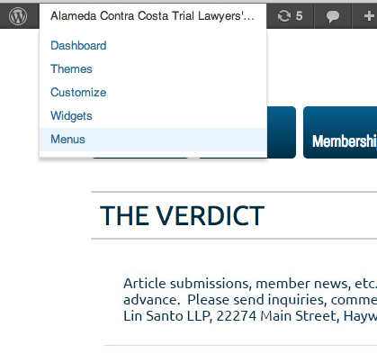

1. Select Which Menu you’d like to edit (i.e. “Primary” for the main navigation )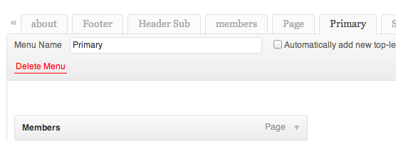
2. Select one or more Page, Location, etc… from the left sidebar and click add to menu.

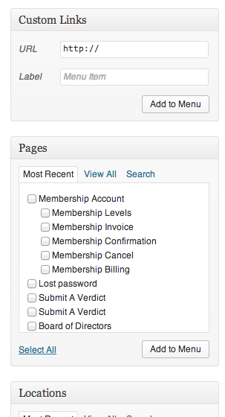

1. Drag and Drop Menu Items to Order. Pull right/left, to create Sub Menus.

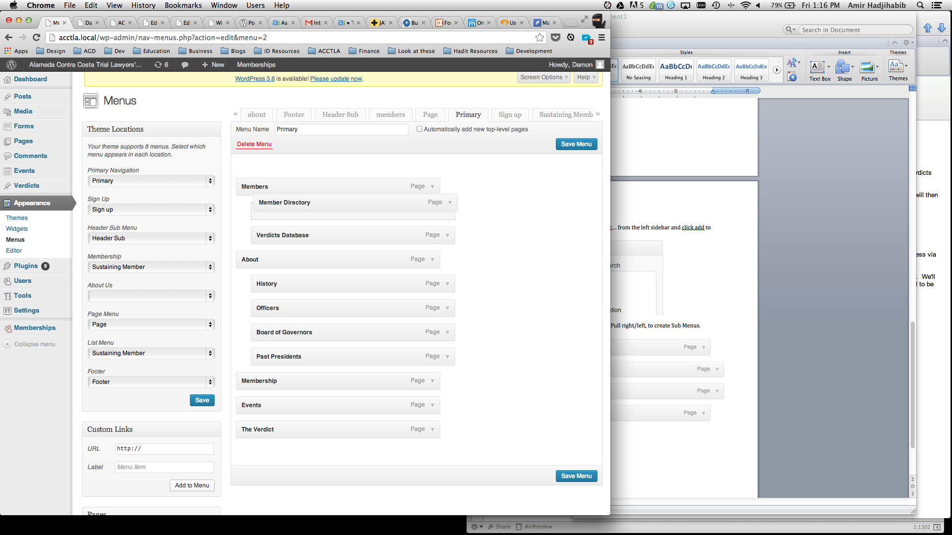

1. Make sure to SAVE MENU every time you make a change.

## Adding/Editing pages

1. Select “Page” From the “+ New” menu in the menubar

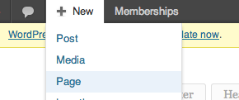

1. Fill out the New Page Admin Form
   1. Title
   2. Content Area
   3. Page Attributes
      1. Parent – If this is a Subpage of another Page of your site, select the Parent page from the dropdown list
      2. Page Template – For normal pages, this will remain untouched, but in certain instances you may need to select an alternate page template (ie. No Sidebar )
      3. Require Membership – If the page is only accessible by certain user level(s), select that user level from here.

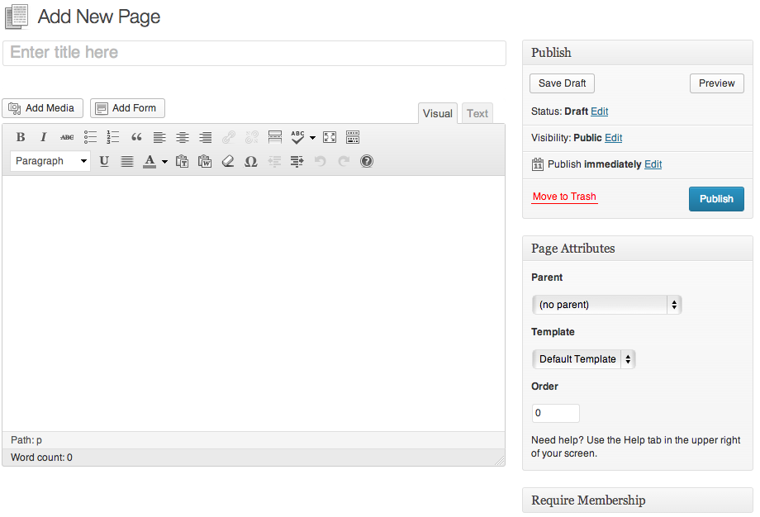

## Adding / Editing Events

1. Select “Event” OR “Recurring Event” from the “+New” Menu

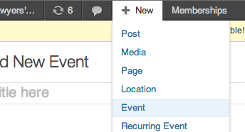

1. Fill out the New Page Admin Form
   1. Title
   2. Content Area – Enter the Event Notes here
   3. Excerpt – Enter Event Description here.
   4. When – Event Date.
   5. Where – Event Location Information
   6. Bookings/Registration – Event Pricing and availability Information
   7. Booking Stats – Information about Booking count and remaining availability

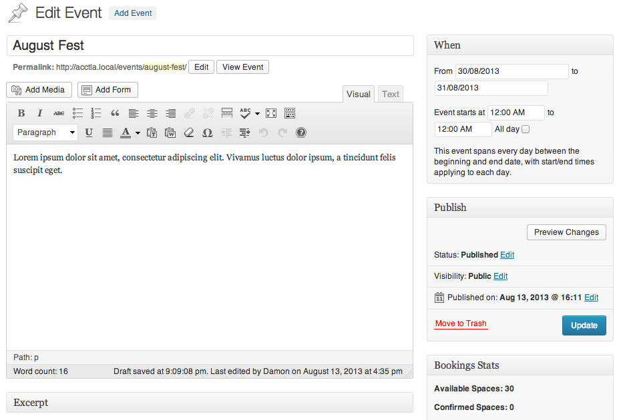

## Adding “The Verdict” Publication

1. Select “The Verdict Publication” from the “+New” Menu
2. Fill out New Form
   1. Title
   2. Media Library – **Drag and Drop** File or **Select Files** via uploader

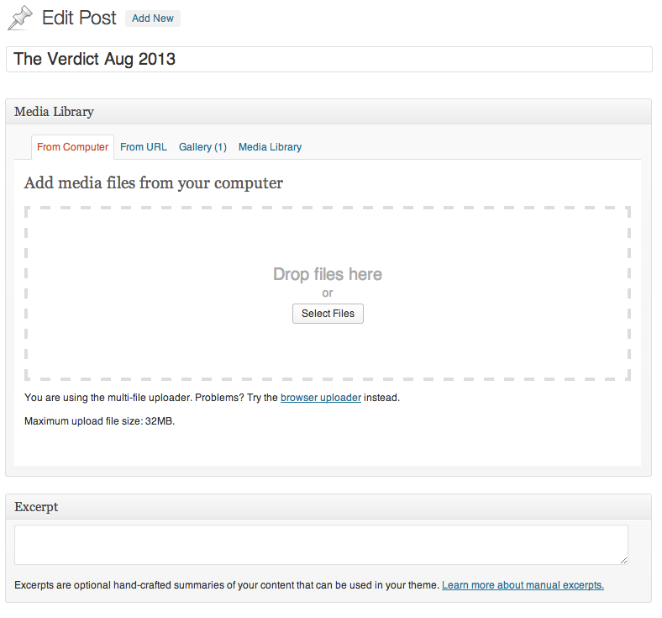

## Creating Cases / Verdicts

1. Navigate to “../submit-a-verdict/”
2. Fill Out all Form Fields.
3. Once Submitted, form will be saved as “Pending Review” and an admin will have to approve and publish the verdict.

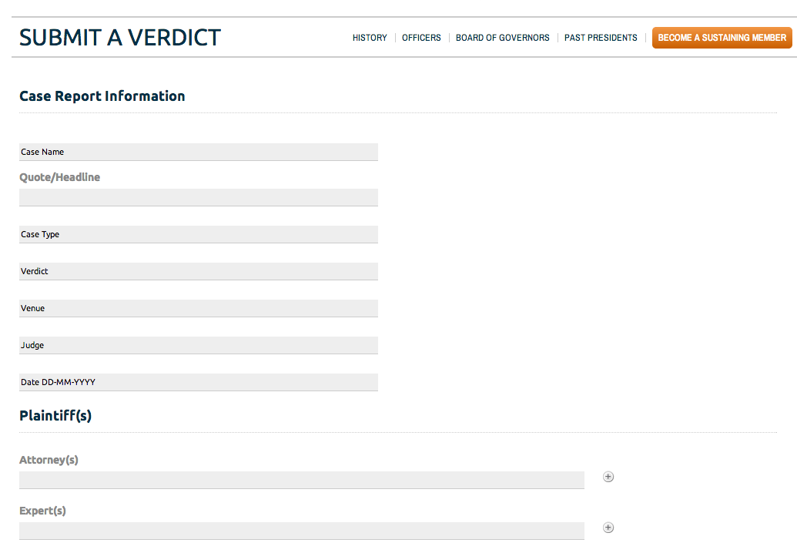

## Creating / Editing Members

1. Navigate to “User” from the “+New” menu

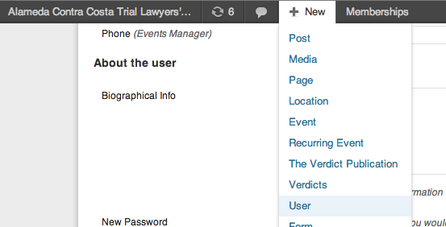

1. Fill out Basic User Info and Click Add New User

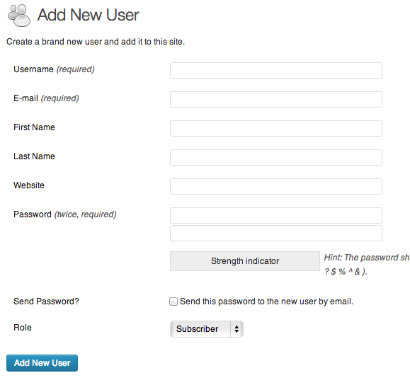

1. You will be taken to the User list screen. Search for your new user and click the name to return the User Edit Form. There will be new user fields available.
   1. Contact Info
   2. About the User
   3. Membership Level
   4. Taxonomies
   5. Avatar
   6. Extra Profile Information
2. To manage Payments and Orders, Navigate to “Memberships “ on bottom left sidebar of the Admin screen. From here you can manage Payments, membership levels, etc.

